Sleep pattern in a sample of obese females and the relation between degree of obesity &severity of sleep diorders and How to diagnose.
Victor Samy Mikhael, Mohamed Mostafa El- Hammady, Shewikar Tawfik El-Bakry and Aml Tarek Shatia,
Department of Neuropsychiatry, Benha Faculty of Medicine, Benha University, Benha Egypt.
aml.tarek.shatia@gmail.com

Abstract : Background : Obesity remains a major health care problem and a leading cause of morbidity and mortality. The relation between obesity and sleep disorders is bidirectional. It is controversial whether obesity causes disturbed sleep or sleep deprivation is the cause for increased weight.
Aim of the study: to detect Sleep disorders in Obese females and to investigate the relationship between it and degree of Obesity, outcome, and methods of diagnosis.
Methods and Results: In this comparative cross-sectional study, fifty obese females (50 females) and twenty age matched control subjects were recruited. Sleep pattern was assessed according to the Standardized Structured Sleep Questionnaire. The severity of obesity was assessed based on Body Mass Index (BMI). Present, Past or Family history of any trials to lose weight was evaluated by a Semistructured Interview. In the current study sleep disorders was higher in obese females when compared to controls. The mean and standard deviation of sleep pattern score were (19.3±5.9) in cases and (11.8±3.0) in controls with Highly significant p value of < 0.001. Subjects with increased degree of obesity had a higher sleep disorder score. Mean value of Morbidly obese was significantly higher than other patients with mean 24.7±7.94whileoverweight patients had lower score with mean 14.5±3.09with highly significant p value of < 0.001.
Conclusion: Increased degree of obesity lead to many sleep disorders such as early morning awakening and loud snoring were highly significant; so those people should be screened for any sleep disturbances.
Key words: Obesity, sleep disorders, basal metabolic index.

1. Introduction
Overweight and obesity are defined by the World Health Organization (WHO) as abnormal or excessive fat accumulation that may impair health. Body mass index (BMI) is a simple index of weight-for-height that is commonly used in classifying overweight and obesity. It is defined as the weight in kilograms divided by the square of the height in meters (kg/m2) ⁽¹⁾.
McAllister et al. (2009)⁽²⁾ provides epidemiological evidence in adults linking the decreasing amount of average sleep to increasing percent of U.S. population that is obese.
Sleep is "a naturally-occurring, reversible, periodic and recurring state in which consciousness and muscular activity is temporarily suspended or diminished, and responsiveness to outside stimuli is reduced ⁽³⁾.
Vorona et al. (2005 ) ⁽⁴⁾ found that in 900 overweight patients, increasing B MI was associated with decreased hours of self-reported sleep per day.
A metaanalysis by Cappucio et al. (2010) ⁽⁵⁾ found that not only quantity but also quality of sleep significantly predicts the risk of developing obesity.
This study has been conducted to evaluate the relation between increased grade of obesity and disordered sleep in Banha, Egypt.
2. Patients and Methods:
This is a cross-sectional comparative study, conducted from August 2016 to February 2016 in Benha University Hospital. Study subjects were informed of the possibility of using the data obtained for academic purpose. Confidentiality was assured to all participants and data used for this study were stripped of personally identifiable information.
Patients:
Study participants were in the age group of 18-55 yrs. Obese patients (n=50) and control subjects (n=20) were recruited for the study. Patients were randomly selected from the internal medicine department or a private diet clinic and controls were matching females working at the hospitals or relatives of the patients. It was ensured that all females participating didn’t suffer from any medical, endocrinal or psychiatric disorders. Excluded were the patients suffering from medical condition, Presence of mental retardation, developmental disability and neurological disorder or psychiatric disorder, Presence of endocrinal or genetic disease causing obesity, Presence of any medical condition or drug administration which can disturb sleep.
Methods:
All patients were subjected to the following: Semistructured Interview that included a present, past and family history of food regimen or operations. Weight, Height, Waist circumference, Hip circumference, Waist\Hip circumference ratio (WHR) and BMI were measured to assess obesity. The Body Mass Index was calculated by (Weight, Kg\Height,m2). Finally, a Standardized Structured Sleep Questionaire the Arabic version (Assad and kahla, 2009) ⁽⁶⁾ was used.
The Structured Sleep Disorder Questionaire consists of 72 questions from which we used only 12 questions

According to BMI obesity is divided into grades, overweight (BMI 25-30) & Mild obesity(BMI 30-34.9) &Moderate obesity (BMI 35-40)and Morbidly obese (BMI >40) ⁽⁷⁾.
Statistical analysis:
The collected data were tabulated and analyzed using SPSS version 16 software (Spss Inc, Chicago, ILL Company). Categorical data were presented as number and percentages while quantitative data were expressed as mean ± standard deviation and range. Chi square test (
X²), or Fisher's exact test (FET) were used to analyze categorical variables. Quantitative data were tested for normality using Shapiro-Wilks test, assuming normality at P>0.05, they were proved to be parametric, so Student "t", ANOVA and Person's correlation coefficient ( r ) were used .The accepted level of significance in this work was stated at 0.05 (P <0.05 was considered significant).
3. Results:
In this study all the participants were females , with mean age ranging from 18 to 55 years. 90% of the patient group (n=50) were married while 10% were not married. 68% of the patients group were Banha and 22% were from outside Banha as shown in table (5).
The mean value of BMI in patients group was higher than control group, 33.8±6.6(range 26.1-52) and 20.6±2.04 (range16-24) respectively. These results were highly significant with p<0.001 (table 1).
A highly significant difference was detected between obese and non-obese as regards Waist circumference with mean (87.2±13.4) in obese females Vs (54.7±5.6) in non-obese females.
A highly significant difference was detected between obese and non-obese as regard BMI where obese had higher BMI with mean (33.8±6.6) in obese females Vs (20.6±2.04) in non-obese females.
In this study the total score of sleep with obese females was higher in score of sleep disorder with mean of (19.3±5.9) compared to control group who had lower score with mean (11.8±3.0) which is a highly significant difference as shown in table (2).
As regards (quality of sleep from patient's view) , 32% of obese females compared to 5 % of control has described their sleep as bad sleep while 28% of obese females compared to 50% of control group has described their sleep as good sleep, while 32% of obese females compared to 25% of control group has described their sleep as moderate sleep, while 8% of obese females compared to 20% of control group has described their sleep as very good sleep which is significantly different as shown in table (3).
In table (4) there were highly significant difference when comparing the studied group regarding total sleep questionnaire score Vs BMI &Weight as shown in the linear relation in figure (5) and (6). While significant difference was detected as regards comparison between total score of sleep pattern and Waist circumference as shown in figure (7).
The grade of obesity among the studied group is shown in figure (2) as Overweight (BMI<30) represent 36% of obese females, Mild obesity (BMI 30-34.9) represent 28% of our study obese females, Moderate obesity (BMI 35-40) represent 20% and Morbid obesity (BMI >40) represents 16%.
Table (1): Comparison of obese females and controls regarding anthropometric measurement.
Variable | Obese group  (N=50) |  | Controls  (N=20) |  | St."t"test | P
 | Mean ±SD | Range | Mean± SD | Range
Weight (kg) | 88.2±12.9 | 65-120 | 59.8±6.0 | 48-70 | 9.4 | <0.001**
Height (m) | 1.62±0.07 | 1.4-1.8 | 1.68±0.07 | 1.6-1.8 | 3.09 | 0.003 *
BMI (kg/m²) | 33.8±6.6 | 26.1-52 | 20.6±2.04 | 16-24 | 8.7 | <0.001**
Waist Circumference (cm) | 87.2±13.4 | 65-120 | 54.7±5.6 | 45-65 | 10.4 | <0.001**
Hip circumference (cm) | 97.7±13.6 | 80-130 | 61.0±5.02 | 50-70 | 11.6 | <0.001**
W/H ratio | 0.89 ± 0.07 | 0.71-1.1 | 0.89±0.04 | 0.75-0.93 | 0.13 | 0.89
** →Highly significant.
*→Significant.
Table 2: Comparison between the studied groups regarding total score of sleep questionaire.
Variable | Obese group  (N=50) |  | Controls  (N=20) |  | St."t" | P
 | Mean ±SD | Range | Mean± SD | Range
Total sleep pattern score (total score of 15 Qs) | 19.3±5.9 | 5-34 | 11.8±3.0 | 5-19 | 5.3 | <0.001**
Table 3: Comparison between the studied groups regarding quality of sleep from patient's view:
 |  |  | Groups |  | Total
 |  |  | Obese | Controls
Quality of sleep | Bad | Count | 16 | 1 | 17
 |  | % within Groups | 32.0% | 5.0% | 24.3%
 | Good | Count | 14 | 10 | 24
 |  | % within Groups | 28.0% | 50.0% | 34.3%
 | Moderate | Count | 16 | 5 | 21
 |  | % within Groups | 32.0% | 25.0% | 30.0%
 | Very good | Count | 4 | 4 | 8
 |  | % within Groups | 8.0% | 20.0% | 11.4%
Total |  | Count | 50 | 20 | 70
 |  | % within Groups | 100.0% | 100.0% | 100.0%
FET=8.64 P=0.03 *
Table 4: Correlation between total score of sleep questionaire and some anthropometric measurements among obese females..
With anthropometric measurements | Total score of sleep pattern
 | r | P
Weight (kg) | 0.519 | <0.001 **
Height (m) | -0.222 | 0.12
BMI (kg/m²) | 0.496 | <0.001 **
Waist Circumference (cm) | 0.412 | 0.003 *
Hip circumference (cm) | 0.315 | 0.026 *
W/H ratio | 0.234 | 0.10

Table 5: Comparison of obese females and controls regarding socio-demographic characters.
Variable |  | Obese group  (N=50) |  | Controls (N=20) |  | Total  (N=70) |  | X²/ Fisher's test | P
 |  | No. | % | No. | % | No. | %
Age (years) | ≤ 45 | 22 | 44.0 | 11 | 55.0 | 33 | 47.1 | 0.69 | 0.41
 | >45 | 28 | 56 | 9 | 45 | 37 | 52.9
Residence | Banha | 34 | 68 | 15 | 75 | 49 | 70 | FET=  2.43 | 0.32
 | Cairo | 6 | 12 | 0 | 0 | 6 | 8.6
 | Menouf | 10 | 20 | 5 | 25 | 5 | 21.4
Occupation | House wife | 33 | 66 | 11 | 55 | 44 | 62.9 | FET=  4.58 | 0.17
 | Manual worker | 8 | 16 | 4 | 20 | 12 | 17.1
 | Teacher | 9 | 18 | 3 | 15 | 12 | 17.1
 | Student | 0 | 0 | 2 | 10 | 2 | 2.9
Marital status | Married | 45 | 90 | 12 | 60 | 57 | 81.4 | FET=  11.1 | 0.004 *
 | Widdow | 4 | 8 | 5 | 25 | 9 | 12.9
 | Divorced | 1 | 2 | 0 | 0 | 1 | 1.4
Smoking | Yes | 0 | 0.0 | 0 | 0.0 | 0 | 0.0 | ------ | --------
 | No | 50 | 100 | 20 | 100 | 70 | 100

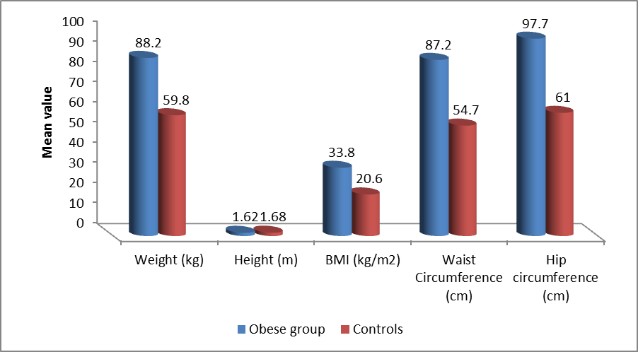
Figure 1:showing the difference in the mean between obese females and control in the anthropometeric data.

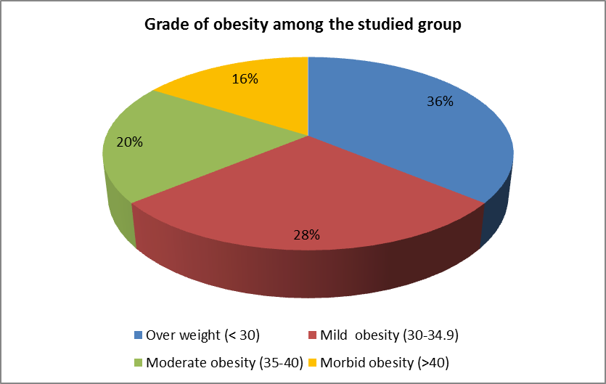
Figure 2: showing grade of obesity among the studied obese female group.

Figure3:showing the comparison between the studied groups as regard total score of sleep questionaire .

Figure4:showing the comparison between the studied groups as regard quality of sleep from patient's view .

Figure 5 :showing the comparison between total score of sleep questionaire and Weight .

Figure 6 :showing the comparison between comparison between total score of sleep questionaire and BMI .

Figure 7 :showing the comparison between comparison between total score of sleep questionaireand Waist circumferance

.

4. Discussion:
Obesity is a risk factor for a wide array of health problems, which include cardiovascular disease, diabetes, cancer, hypertension, stroke, respiratory problems, and sleep apnea ⁽⁸⁾. Among Egyptians above the age of the age of 15 there are more overweight and obese females than there are males.
According to WHO statistics, an estimated 76 percent of females in this age group are said to be overweight or obese, in comparison with approximately 64.5% of Egyptian males. Indicators reveal that the rate of obesity in Egypt has risen markedly over the past 30 years ⁽⁹⁾.
In is comparative cross-sectional study carried out at Benha University Hospital on 50 obese female patients and 20 controls, the age of the studied sample was (18-55) years versus (66.7±8.3) years with significant increase sleep disorders with increased grade of obesity .
This result agreed with Marshall, et al. ⁽¹⁰⁾ who found that Poor sleep predicts obesity in adults especially females.
The decision to choose females was in line with Lovejoy Jc.et al. ⁽¹¹⁾ who admitted that Obesity prevalence is generally higher in women than in men .

Moderately obese individuals have an average life expectancy of 2 to 5 years less than those who are not overweight or obese. Severely obese individuals have a life expectancy up to 20 years less than those not overweight or obese ⁽¹²⁾
The increased rates of hypertension, diabetes, sleep disorders and dyslipidemia could shorten longevity by as much as 5 years in the US ⁽¹³⁾.
So, our study gave highlights on the effect of obesity on health &its relation to disordered sleep and how to treat both.
Slane,et al. ⁽¹⁴⁾ found that Sleep disturbances were highly prevalent (50.3%) among 400 female patients diagnosed with (high BMI) obesity.
This finding also was in line with a relatively small study, came in December 2004 when a University of Chicago researcher in endocrinology, Eve Van Cauter ⁽¹⁵⁾ found that poor sleep disrupted two hormones associated with appetite and lead to obesity.
In this study, Incidence of Obstructive sleep apnea (OSA) was higher in obese females more than controls, which was a statistically significant result.
This agreed with Walker,,et al. ⁽¹⁶⁾ who found that Obesity may be the most important risk factor for OSA.Women with OSA are more likely to be obese than are men with OSA of similar severity.
In the current study a significant difference was detected between the studied group with higher incidence in obese females as regard the obesity hypoventilation syndrome(OHS).
OHS is concurrent with OSA but in OHS sleepiness may be worsened by elevated blood levels of carbon dioxide, which causes drowsiness ("CO2 narcosis"). Other symptoms present in both conditions are depression, and hypertension (high blood pressure) that is difficult to control with medication⁽¹⁹⁾ .
The low oxygen level leads to excessive strain on the right side of the heart, known as cor pulmonale ⁽²⁰⁾ .
Formal criteria for diagnosis of OHS are (BMI > 30 kg/m2) and arterial carbon dioxide level >45 mmHg or 6.0 kPa as determined by arterial blood gas measurement⁽¹⁸⁾. In people with stable OHS, the most important treatment is weight loss—by diet, through exercise, with medication, or sometimes weight loss surgery (bariatric surgery). This has been shown to improve the symptoms of OHS and resolution of the high carbon dioxide levels. If the symptoms are significant, nighttime positive airway pressure (PAP) treatment is tried; this involves the use of a machine to assist with breathing ⁽¹⁹⁾ .
In our study a highly significant difference between the studied groups with higher incidence of snoring among the obese group as noticed by their partner.
A highly significant difference was found as regards Early morning insomnia which is higher in obese group.
This agreed with Laboratory studies demonstrate that experimentally induced hunger has sleep-disruptive effects. Hunger induced by food deprivation produces increased nocturnal wakefulness and reduced slow wave sleep⁽²³⁾ .

In a cross-sectional study of 78 morbidly obese patients without OSA, Resta et al ⁽¹⁷⁾ reported that the majority of participants complained of frequent choking (25%), awakenings (50%), unrefreshing sleep (50%), and loud snoring (46.7%). Moreover, 35% had excessive daytime sleepiness without concomitant increase in the arousal index.
In our study, a significant difference between the studied groups with higher incidence of daytime sleepiness and difficulty to finish daytime activities among the obese group rather than the control group.
In this study, there was a significant increase in having Nightmares within obese patients with 11% of the study group compared to 3% of controls who showed less nightmares .
In this research a non significant difference between the studied groups of rest less leg syndrome among the obese group and the control group.
This disagreed with Rothdach,et al . . ⁽²¹⁾ who found in a Prospective cohort data suggest that 11.7% of obese women are affected, and overall prevalence is higher among women(13.9%) than men (6.1%) in another cohort analysis.
Using the standerized sleep questionnaire the total score of sleep with obese females had higher score of sleep disorder with mean of (19.3±5.9) compared to control group who had lower score with mean (11.8±3.0) which is a highly significant value.
This agreed with Leproult ,et al. ⁽²²⁾ who found a significant association between short sleep (generally <6 h per night) and increased obesity risk.
A highly significant difference was detected as regards comparison between total score of sleep pattern and Weight and BMI.
These findings agreed with other studies, Magee,et al. set a small cohort demonstrated that in men, but not women, increased work hours were associated with higher BMI ⁽²³⁾, and Buxton,et al ⁽²⁴⁾, demonstrated a 6% increase in the probability of obesity in 56 507 US adults with a wide age range (18–85 years) for self-reported sleep duration of less than 7 h per night.
A recent single study objectively measured sleep duration by full-night polysomnography and demonstrated an inverse correlation between sleep time and both waist circumference. These associations were stronger in women less than 50 years old ⁽²⁵⁾.
This agreed with our study which found a significant difference was detected as regard comparison between total score of sleep pattern and Waist circumference& Hip circumferance.

There is no Egyptian study carried out in our subject . Shiny Parsai, et al . from Iowa university at the year 2011 carried out a study on the same subject which revealed that females in all categories were not getting adequate amounts of sleep as recommended by the National Sleep Foundation (2011), thus suggesting that from a public health perspective, we need to encourage women to get more sleep, perhaps a greater emphasis needs to be placed on public health messaging to encourage adequate sleep for all
individuals.
Limitations met while conducting this study were: (1) This is not a population-based study. It is a single-center cross-sectional study restricted to a local hospital, based on the data collected from a small number of obese patients, which may not accurately reflect the majority of other population. (2) Although cases were matched with control subjects regarding age and sex yet there was not matched in work condition or home condition,which could affect the sleep pattern irrespective of obesity. (3) Nicotine as a indirect smoking and caffeine may act as confounding factors affecting the sleep profile of casas. (4) The questionnaire ask the cases about sleep profile from there point of view, so the results were not accurate .

Conclusion and recommendation:
Our study concluded that females with obesity suffer from sleep disturbances,As loud snoring and early morning awakening were found highly significant in those patients. Sleep laboratory studies and multiple epidemiological studies have linked short-sleep duration and poor-sleep quality to obesity risk with increasing severity as obesity grade increases (i.e. Moderatly and Morbidly obese patients show more sleep disturbances as compared to overweight females ).
With the growing prevalence of chronic sleep loss, any causal association between sleep alterations and obesity would have important public health implications..
Currently, there is a lack of interventional studies in real life conditions aimed at increasing sleep duration and improving sleep quality in order to prevent weight gain or facilitate weight loss.
Sleep is essential for women to live a functional, productive life. Diagnostic evaluations should be performed and, if needed, treatment prescribed when sleep is disturbed.
sleep disorders can be improved, and in some cases eliminated completely, by a good regime of sleep hygiene. In fact, cognitive behavioural therapy (CBT), the workhorse of most modern approaches to dealing with sleep disorders, consists of two main parts: firstly, convincing a patient that their problems are manageable, and secondly establishing a good system of sleep hygiene.

Acknowledgement:
We acknowledge all the patients who gave their consent to be part of this study. We are thankful to the entire staff of neuropsychiatry department in Benha University Hospital for their consistent support and help.

References:
- WHO. January 2015. Retrieved 2 February 2016"Obesity and overweight Fact sheet N°311".
- McAllister EJ, and Dhurandhar NV,(2009) . Ten putative contributors to the obesity epidemic. Critical Reviews in Food Science and Nutrition. 2009 Nov;49(10):868–913.
- Randall (19 September 2012). "Book excerpt: How the lightbulb disrupted our sleeping patterns and changed the world". National Post. Retrieved 31 August 2016. "... the sudden introduction of bright nights during hours when it should be dark threw a wrench into a finely choreographed system of life.
- Vorona RD, and Winn MP,(2005). Overweight and obese patients in a primary care population report less sleep than patients with a normal body mass index. Archives of Internal Medicine. 2005 Jan 10;165(1):25–30.
- Cappuccio FP, and D’elia L, et al., (2009). Quantity and quality of sleep and incidence of obesity: a systematic review and meta-analysis. Diabetes Care. 2010 Feb; 33(2):414–20. Epub 2009 Nov 12.
- Asaad and kahla (2009):Standardized Structured Sleep Questionaire.
أ.د. ألفت كحلة(استشاري التقييم والعلاج النفسي).
تأليف:أ.د.طارق أسعد. (أستاذ الأمراض النفسية)
دار النشر :إيتراك للطباعة والنشر والتوزيع(2009).
((كتاب النوم) المشكلات -التشخيص -العلاج.
- AuneD. Sen, A et al,2016. "BMI and all cause mortality: systematic review and non-linear dose-response meta-analysis of 230 cohort studies with 3.74 million deaths among 30.3 million participants.". BMJ (Clinical research ed.). 353: i2156. doi:10.1136/bmj.i2156.
- Center for Disease Control and Prevention. Health Consequences [Internet]. Atlanta, GA: Center for Disease Control and Prevention; c2011a [cited 2011 March 3]. Available from: http://www.cdc.gov/obesity/causes/health.html
9) WHO. January 2015. Retrieved 2 February 2016. "Obesity and overweight Fact sheet N°311".
10) Marshall NS, Glozier N, Grunstein RR. Is sleep duration related to obesity? A critical review of the epidemiological evidence. Sleep Medicine Reviews. 2008 Aug;12(4):289–98.Epub 2008 May 15.
11)Lovejoy JC, Sainsbury A; Stock Conference 2008 Working Group.
12)National Institutes of Health (NIH). Obesity Threatens to Cut U.S. Life Expectancy, New Analysis Suggests [Internet]. c2005 [cited 2011 June 15]. Available from:
http://www.nih.gov/news/pr/mar2005ia-16.htm.
13)Wyatt SB, Winters KP, Dubbert PM. Overweight and obesity: prevalence, consequences, and causes of the growing public health problem. The American Journal of Medical Sciences. 2006 Apr;331(4):166-74.
14) Slane, Burt & Klump, 2010, Baglioni, Battagliese, Feige, Spiegelhalhalder, Nissen, Voderholzer, Lombardo & Riemann, 2011.
15) Eve Van Cauter & Karine Spiegel (1999). "Circadian and Sleep Control of Hormonal Secretions", in Turek & Zee (eds.), Regulation of Sleep and Circadian Rhythms, pp. 397–425 Chamorro Á, Amaro S, MD, Castellanos M et al., (2014).
16) Walker RP, Durazo-Arvizu R, Wachter B, et al. Preoperative differences between male and female patients with sleep apnea. Laryngoscope 2001;111:1501Y1505

17) Resta O, Foschino Barbaro MD, Bonfitto P, et al. Low sleep quality and daytime sleepiness in obese patients without obstructive sleep apnoea syndrome. J Intern Med. 2003;253:536-543.

..18) Olson AL, Zwillich C (2005). "The obesity hypoventilation syndrome" . Am. J. Med. 118 (9): 948–56. doi:10.1016/j.amjmed.2005.03.042 . PMID 16164877 .
19)Mokhlesi B, Tulaimat A (October 2007). "Recent advances in obesity hypoventilation syndrome" . Chest. 132 (4): 1322–36. doi:10.1378/chest.07-0027 . PMID 17934118.
20) Ohno& Sakurai, 2008.

21)Rothdach AJ, Trenkwalder C, Haberstock J, et al. Prevalence and riskfactors of RLS in an elderly population: the MEMO study.
22)Leproult R, Van Cauter E. Role of sleep and sleep loss in hormonal release and metabolism. Endocr Dev. 2010;17:11–21. [PMC free article] [PubMed]Amaro S, Urra X, Gómez-Choco M, et al., (2011).
23) Magee CA, Caputi P, Iverson DC. Is sleep duration associated with obesity in older Australian adults? J Aging Health. 2010;22:1235–1255. [PubMed
24) Buxton OM, Marcelli E. Short and long sleep are positively associated with obesity, diabetes, hypertension, and cardiovascular disease among adults in the United States. Soc Sci Med. 2010;71:1027–1036. [PubMed]
25)Theorell-Haglow J, Berne C, Janson C, et al. Associations between short sleep duration and central obesity in women. Sleep. 2010;33:593–598. [PMC free article] [PubMed

